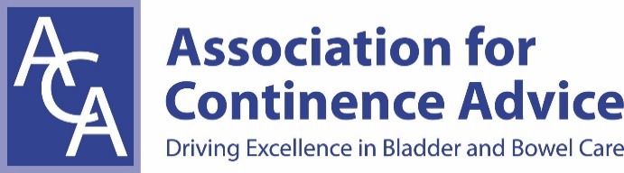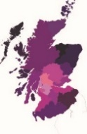
ACA Scotland AGM & Study Day: Neurogenic Bowel
MARCH 10TH 2017, STIRLING COURT HOTEL
Delegate Registration Form and Payment Instructions
First Name: Surname:
ACA Membership No (if applicable): ……………………………………………..
Job Title:
Place of Work:
Email Address:
Telephone Number:
Correspondence Address:
Postcode:
Please tick appropriate boxes below:
Non Member Study Day Fee only £50.00 | Cheque | BACS | Confirmed (office use only):
Member Study Day - free | Please tick | Confirmed (office use only):
Email Registration Form to: kate.boyce54@gmail.com
Please make cheques payable to ACA General (write ‘Scotland 10/3’ on the back) and send to:
Brian Young, ACA Scotland Treasurer, 1 Temple Mains Steading, Innerwick, EH42 1EF

Or, why not consider joining the ACA for £50 a year and get this and many more sessions for free as well member benefits. Contact kate.boyce54@gmail.com for more information

