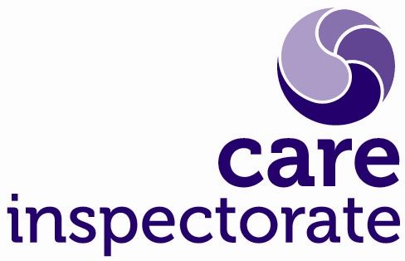
Equalities Monitoring Form

We are committed to recruiting, retaining and developing a workforce that reflects the diverse communities that we help to protect. It is vital that we monitor and analyse diversity information so that we can ensure that our human resources (HR) processes are fair, transparent, promote equality of opportunity for all staff in accordance with the Equality Act (2010).

To assist us to monitor the effectiveness of our equality and diversity practices, we would encourage you to complete this monitoring form.

The information you provide us with will stay strictly confidential, be stored securely and limited to colleagues in HR.

Privacy: We respect your privacy and will only use personal information collected to support the recruitment process in accordance with Data Protection legislation. To find out how we will handle your personal information please read our privacy notice available on our website.

We will separate this form from your application prior to the selection process.

Please tick the relevant box in each section which you feel most describes you or if you do not want to answer any specific question(s) tick ‘Prefer not to say’.

Surname: |  | Initials:
Title of Post:
Location of Post:

What is your age?
Under 21 years
21 – 29 years
30 – 39 years
40 - 49 years
50 – 59 years
60 – 65 years
Over 65 years
Prefer not to say

Do you consider yourself to have a disability?
Disability is defined by the Equality Act 2010 as a physical or mental impairment, which has a substantial and long term (has lasted or is expected to last at least 12 months) and has an adverse effect on a person’s ability to carry out normal day-to-day activities
Yes

If yes, please specify below

- Physical impairment, such as difficulty using your arms or mobility issues which means using a wheelchair or crutches

- Sensory impairment, such as being blind/having serious visual impairment or being deaf/having serious hearing impairment

- Mental health condition such as depression or schizophrenia

- Learning disability, such as down syndrome or dyslexia or cognitive impairment such as autism or head injury

- Long standing illness or health condition such as cancer, HIV, diabetes, chronic heart disease or epilepsy

No
Don’t know
Prefer not to say

What is your gender?
Male (including trans men)
Female (including trans women)
Other gender identity (e.g. androgyne person)
Prefer not to say
Is your gender identify the same as you were assigned at birth?
Yes
No
Prefer not to say
Have you ever identified as a transgender person?
Yes
No
Prefer not to say

What is your religion or belief?
None
Church of Scotland
Roman Catholic
Other Christian…………………………………
Muslim
Buddhist
Sikh
Jewish
Hindu
Other (please state) ……..........................................................................................
Prefer not to say

What is your sexual orientation?
Bisexual
Gay / Lesbian
Heterosexual
Other (please state) ……..........................................................................................
Prefer not to say

What is your ethnic group?
Group A: White
Scottish
British
Irish and Northern Irish
Polish
Gypsy Traveller
Other white ethnic group (please state) ……………………………………………….
Group B: Mixed or multiple ethnic groups
Any mixed or multiple ethnic group (please state) …………………………………..
Group C: Asian, Asian Scottish or Asian British
Pakistani, Pakistani Scottish or Pakistani British
Indian, Indian Scottish or Indian British
Bangladeshi, Bangladeshi Scottish or Bangladeshi British
Chinese, Chinese Scottish or Chinese British
Other (please state) ……..........................................................................................
Group D: African, African Scottish or African British
African, African Scottish or African British
Other (please state) ……..........................................................................................
Group E: Caribbean or Black
Caribbean, Caribbean Scottish or Caribbean British
Black, Black Scottish or Black British
Other (please state) ……..........................................................................................
Group F: Other ethnic group
Arab, Arab Scottish or Arab British
Prefer not to say

What is your marriage or civil partnership status?
Single
Married
Separated
Divorced
Co-habiting
Widowed
In a same sex civil partnership
Other (please state) ……..........................................................................................
Prefer not to say

Are you a carer?
Yes
No
Don’t know
Prefer not to say

Thank you for completing this form.

