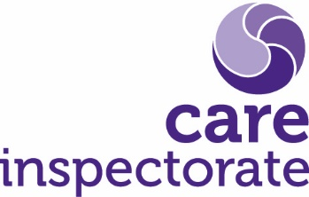

**Joint inspections of services for children and young people at risk of harm**

**Framework for support and post scrutiny response**

**Publication date: June 2024**

**Review date : June 2025**

**Publication code: 014**

**Strategic scrutiny - framework for support and post strategic scrutiny response**

**Introduction**

The Care Inspectorate’s strategic teams have developed this framework as a tool to assist in deciding the most appropriate post scrutiny response or approach to post scrutiny support. While not the explicit purpose of this document, partnerships may also find it helpful to support their own decision making relating to self-evaluation and improvement activities.

In addition to scrutiny functions, [section 44 (1) (b) of the Public Services Reform (Scotland) Act 2010](https://www.legislation.gov.uk/asp/2010/8/section/44) places a general duty on the Care Inspectorate of furthering improvement in the quality of social services. At the conclusion of joint or strategic inspections, inspection teams consider the level of confidence in a partnership’s ability to make any improvements that have been identified through the course of the scrutiny. The framework provides a means for approaching this discussion in a structured and consistent way.

**Framework**

The framework acknowledges and draws from published Local Government Association commissioned research “[Enabling improvement: research into the role and models of external improvement support for local children’s services](https://www.local.gov.uk/sites/default/files/documents/Enabling%20Improvement.pdf)” (Local Government Association / ISOS Partners 2017), adapted for the Scottish scrutiny and inspection landscape. It is informed by existing Care Inspectorate learning about strategic planning [10 steps to successful children’s services planning](https://www.gov.scot/publications/children-young-people-scotland-act-2014-statutory-guidance-part-3-childrens-services-planning-second-edition-2020/pages/16/). The framework is founded on the principle of five conditions of improvement (see Appendix One), that partnerships are able to:

* self-assess accurately
* self-evaluate to secure improvement
* develop strategic priorities
* implement strategic priorities
* evaluate progress towards achieving improvement

A number of criteria are provided in the framework to help understand the extent to which a partnership meets each of these conditions. An assessment is necessary to determine the level of support required to make the improvements. The framework sets out four levels of support:

* local partnership led improvement
* commissioned improvement support
* assisted improvement support
* directed improvement support

Where the majority of criteria in four or more of the conditions of improvement are met, the partnership is likely to be able to lead and make the required improvements with little or no

support. By contrast, where the majority of criteria or fewer are met in only one condition, the indication would be that the partnership requires support for the improvements required.

The framework outlines the aims and potential benefits at each level of support (see Appendix Two) as well as the characteristics of what the support may include (see Appendix Three).

Please note that within the framework, the term “scrutiny partners” is defined as the Care Inspectorate and any scrutiny body working with the Care Inspectorate to undertake strategic scrutiny.

**Appendix One**

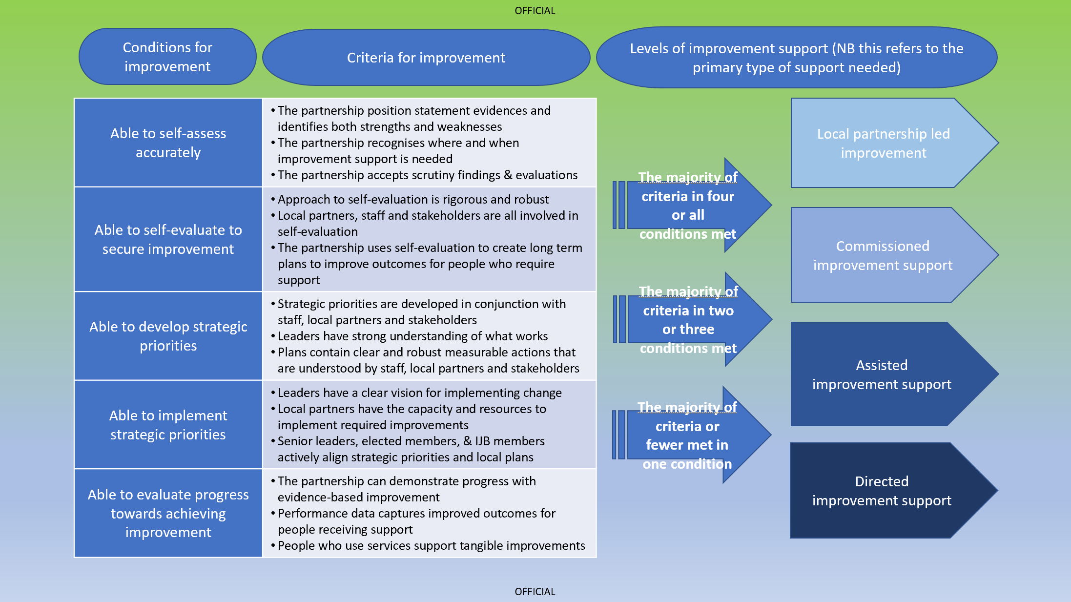

**Appendix Two**

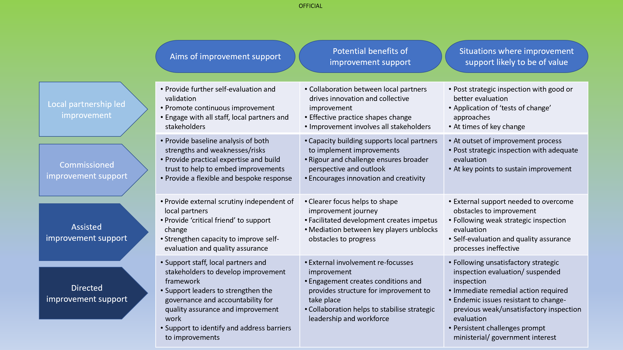

**Appendix Three**

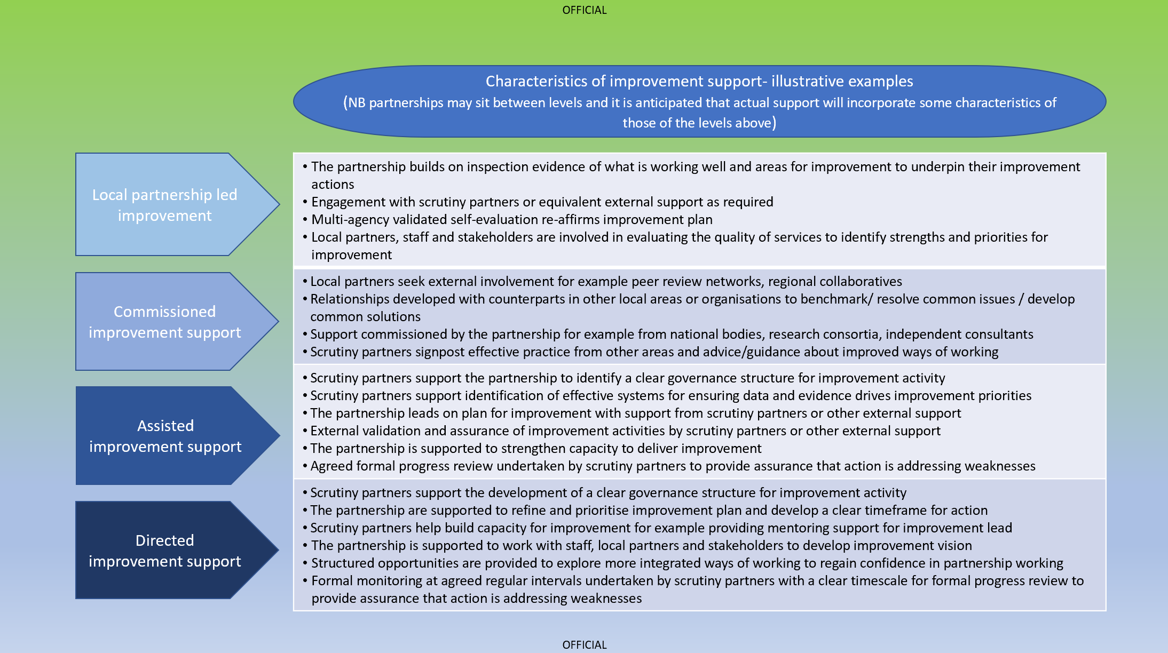

**Headquarters**

Care Inspectorate

Compass House

11 Riverside Drive

Dundee

DD1 4NY

**web:** [**www.careinspectorate.com**](http://www.careinspectorate.com)

**email:** [**enquiries@careinspectorate.com**](mailto:enquiries@careinspectorate.com)

**telephone: 0345 600 9527**

**@careinspect**

**Other languages and formats**



Copyright of Care Inspectorate 2024 